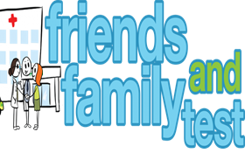

**HAVE YOUR SAY TO IMPROVE YOUR CARE!**

COMPLETE OUR SHORT QUESTIONNAIRE ON HOW LIKELY YOU ARE TO RECOMMEND OUR SURGERY TO FAMILY AND FRIENDS.

**We have been collecting your replies and below are our results for**

**September 25**

|  |  |  |  |  |  |
| --- | --- | --- | --- | --- | --- |
| **Very Good** | **Good** | **Neither Good/nor poor** | **Poor** | **Very Poor** | **Don’t Know** |
| 15 | 1 | 3 | 0 | 0 | 0 |

Recent comments:

|  |  |  |  |  |  |  |  |  |  |  |  |  |  |  |  |  |  |  |
| --- | --- | --- | --- | --- | --- | --- | --- | --- | --- | --- | --- | --- | --- | --- | --- | --- | --- | --- |
| * All staff very friendly and efficient, excellent appointment service.      * Dr’s give time and care to their patients. * Quick response and good explanation from the Dr’s. * Best surgery in the UK, basically perfect. * Been with the surgery 26 years everyone is lovely. | | | | | | | |  |  |  |  |  |  |  |  |  |  |  |
|  | | | | | | | | | | | |  |  |  |  |  |  |  |
|  | | | | | | | | | | | | | | | | | | |
|  |  |  |  |  |  |  |  |  |  |  |  |  |  |  |  |  |  |  |