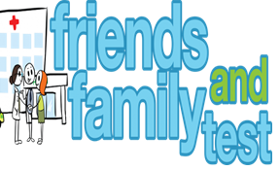

**HAVE YOUR SAY TO IMPROVE YOUR CARE!**

COMPLETE OUR SHORT QUESTIONNAIRE ON HOW LIKELY YOU ARE TO RECOMMEND OUR SURGERY TO FAMILY AND FRIENDS.

**We have been collecting your replies and below are our results for**

**July 24**

|  |  |  |  |  |  |
| --- | --- | --- | --- | --- | --- |
| **Very Good** | **Good** | **Neither Good/nor poor** | **Poor** | **Very Poor** | **Don’t Know** |
| 32 | 3 | 3 | 0 | 0 | 1 |

Recent comments:

|  |  |  |  |  |  |  |  |  |  |  |  |  |  |  |  |  |  |  |
| --- | --- | --- | --- | --- | --- | --- | --- | --- | --- | --- | --- | --- | --- | --- | --- | --- | --- | --- |
| * Very Responsive. * New to this surgery wish I changed 40 years ago! * Excellent Surgery. * The best surgery I have ever been to. * Everyone very kind and polite. * We have always had excellent service at this surgery. * Very kind and patient nurse. | | | | | | | |  |  |  |  |  |  |  |  |  |  |  |
|  | | | | | | | | | | | |  |  |  |  |  |  |  |
|  | | | | | | | | | | | | | | | | | | |
|  |  |  |  |  |  |  |  |  |  |  |  |  |  |  |  |  |  |  |