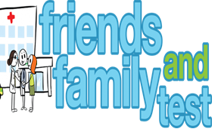

**HAVE YOUR SAY TO IMPROVE YOUR CARE!**

COMPLETE OUR SHORT QUESTIONNAIRE ON HOW LIKELY YOU ARE TO RECOMMEND OUR SURGERY TO FAMILY AND FRIENDS.

**We have been collecting your replies and below are our results for**

**May 25**

|  |  |  |  |  |  |
| --- | --- | --- | --- | --- | --- |
| **Very Good** | **Good** | **Neither Good/nor poor** | **Poor** | **Very Poor** | **Don’t Know** |
| 19 | 6 | 0 | 0 | 0 | 0 |

Recent comments:

|  |  |  |  |  |  |  |  |  |  |  |  |  |  |  |  |  |  |  |
| --- | --- | --- | --- | --- | --- | --- | --- | --- | --- | --- | --- | --- | --- | --- | --- | --- | --- | --- |
| * The doctors and staff are great this is why i come here. * Simply the best surgery in the area. * All staff are amazing. * Super attentive and very professional thank you all. * This surgery is amazing, I feel so lucky to be registered here. * Always prompt and accurate. | | | | | | | |  |  |  |  |  |  |  |  |  |  |  |
|  | | | | | | | | | | | |  |  |  |  |  |  |  |
|  | | | | | | | | | | | | | | | | | | |
|  |  |  |  |  |  |  |  |  |  |  |  |  |  |  |  |  |  |  |