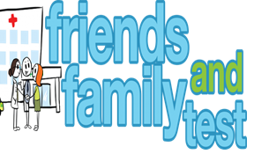

**HAVE YOUR SAY TO IMPROVE YOUR CARE!**

COMPLETE OUR SHORT QUESTIONNAIRE ON HOW LIKELY YOU ARE TO RECOMMEND OUR SURGERY TO FAMILY AND FRIENDS.

**We have been collecting your replies and below are our results for**

**September 24**

|  |  |  |  |  |  |
| --- | --- | --- | --- | --- | --- |
| **Very Good** | **Good** | **Neither Good/nor poor** | **Poor** | **Very Poor** | **Don’t Know** |
| 23 | 0 | 1 | 0 | 0 | 0 |

Recent comments:

|  |  |  |  |  |  |  |  |  |  |  |  |  |  |  |  |  |  |  |
| --- | --- | --- | --- | --- | --- | --- | --- | --- | --- | --- | --- | --- | --- | --- | --- | --- | --- | --- |
| * Absolutely fantastic in every way thoroughly checking my issues. * Dr’s all very good. * Very polite and helpful and I even got a drink of water. * Always excellent care, not long to wait for appointments. * Excellent surgery! * New to the practice no problems. * Always answer the phone and are kind and caring. | | | | | | | |  |  |  |  |  |  |  |  |  |  |  |
|  | | | | | | | | | | | |  |  |  |  |  |  |  |
|  | | | | | | | | | | | | | | | | | | |
|  |  |  |  |  |  |  |  |  |  |  |  |  |  |  |  |  |  |  |