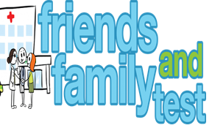

**HAVE YOUR SAY TO IMPROVE YOUR CARE!**

COMPLETE OUR SHORT QUESTIONNAIRE ON HOW LIKELY YOU ARE TO RECOMMEND OUR SURGERY TO FAMILY AND FRIENDS.

**We have been collecting your replies and below are our results for**

**November 24**

|  |  |  |  |  |  |
| --- | --- | --- | --- | --- | --- |
| **Very Good** | **Good** | **Neither Good/nor poor** | **Poor** | **Very Poor** | **Don’t Know** |
| 15 | 1 | 0 | 0 | 0 | 0 |

Recent comments:

|  |  |  |  |  |  |  |  |  |  |  |  |  |  |  |  |  |  |  |
| --- | --- | --- | --- | --- | --- | --- | --- | --- | --- | --- | --- | --- | --- | --- | --- | --- | --- | --- |
| * Attention to detail, friendly efficient service. * Extra care always taken when dealing with sensitive issues. * Very good reception staff always professional and friendly. * Great service very responsive lovely team. * Best Doctors ever always so helpful. * Dr Mugglestone is great. * Always answer the phone and are kind and caring. | | | | | | | |  |  |  |  |  |  |  |  |  |  |  |
|  | | | | | | | | | | | |  |  |  |  |  |  |  |
|  | | | | | | | | | | | | | | | | | | |
|  |  |  |  |  |  |  |  |  |  |  |  |  |  |  |  |  |  |  |