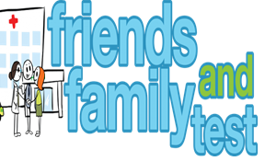

**HAVE YOUR SAY TO IMPROVE YOUR CARE!**

COMPLETE OUR SHORT QUESTIONNAIRE ON HOW LIKELY YOU ARE TO RECOMMEND OUR SURGERY TO FAMILY AND FRIENDS.

**We have been collecting your replies and below are our results for**

**March 25**

|  |  |  |  |  |  |
| --- | --- | --- | --- | --- | --- |
| **Very Good** | **Good** | **Neither Good/nor poor** | **Poor** | **Very Poor** | **Don’t Know** |
| 31 | 1 | 1 | 1 | 1 | 0 |

Recent comments:

|  |  |  |  |  |  |  |  |  |  |  |  |  |  |  |  |  |  |  |
| --- | --- | --- | --- | --- | --- | --- | --- | --- | --- | --- | --- | --- | --- | --- | --- | --- | --- | --- |
| * The staff are excellent and diligent * Never a problem. * Nice staff and doctors. * Got an appointment straight away. Brilliant surgery. * I have no complaints, everyone is great. * Outstanding from all staff. * This surgery is the best! | | | | | | | |  |  |  |  |  |  |  |  |  |  |  |
|  | | | | | | | | | | | |  |  |  |  |  |  |  |
|  | | | | | | | | | | | | | | | | | | |
|  |  |  |  |  |  |  |  |  |  |  |  |  |  |  |  |  |  |  |