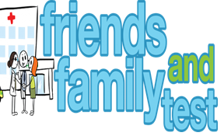

**HAVE YOUR SAY TO IMPROVE YOUR CARE!**

COMPLETE OUR SHORT QUESTIONNAIRE ON HOW LIKELY YOU ARE TO RECOMMEND OUR SURGERY TO FAMILY AND FRIENDS.

**We have been collecting your replies and below are our results for**

**December 24**

|  |  |  |  |  |  |
| --- | --- | --- | --- | --- | --- |
| **Very Good** | **Good** | **Neither Good/nor poor** | **Poor** | **Very Poor** | **Don’t Know** |
| 32 | 4 | 0 | 0 | 0 | 2 |

Recent comments:

|  |  |  |  |  |  |  |  |  |  |  |  |  |  |  |  |  |  |  |
| --- | --- | --- | --- | --- | --- | --- | --- | --- | --- | --- | --- | --- | --- | --- | --- | --- | --- | --- |
| * The doctors are very caring and will go above and beyond for their patients * Always able to get an appointment, unlike other surgeries. * The practice gives excellent service to patients. * All staff go above and beyond * Reception team all very helpful. * Fantastic :) * Sue Tindall is great and very helpful. | | | | | | | |  |  |  |  |  |  |  |  |  |  |  |
|  | | | | | | | | | | | |  |  |  |  |  |  |  |
|  | | | | | | | | | | | | | | | | | | |
|  |  |  |  |  |  |  |  |  |  |  |  |  |  |  |  |  |  |  |