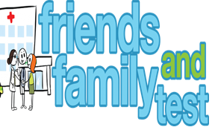

**HAVE YOUR SAY TO IMPROVE YOUR CARE!**

COMPLETE OUR SHORT QUESTIONNAIRE ON HOW LIKELY YOU ARE TO RECOMMEND OUR SURGERY TO FAMILY AND FRIENDS.

**We have been collecting your replies and below are our results for**

**June 24**

|  |  |  |  |  |  |
| --- | --- | --- | --- | --- | --- |
| **Very Good** | **Good** | **Neither Good/nor poor** | **Poor** | **Very Poor** | **Don’t Know** |
| 26 | 2 | 0 | 0 | 0 | 0 |

Recent comments:

|  |  |  |  |  |  |  |  |  |  |  |  |  |  |  |  |  |  |  |
| --- | --- | --- | --- | --- | --- | --- | --- | --- | --- | --- | --- | --- | --- | --- | --- | --- | --- | --- |
| * Excellent and prompt service. * Receptionists are lovely. * All staff very kind and helpful. * Always consistent and can get an appointment * Excellent practice. * I was poorly in Austria, appointment arranged for when I was back! * Always an excellent response, very caring doctors. | | | | | | | |  |  |  |  |  |  |  |  |  |  |  |
|  | | | | | | | | | | | |  |  |  |  |  |  |  |
|  | | | | | | | | | | | | | | | | | | |
|  |  |  |  |  |  |  |  |  |  |  |  |  |  |  |  |  |  |  |